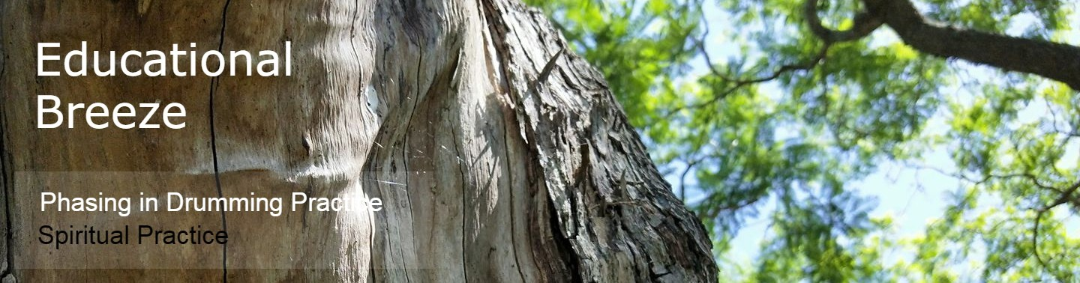

Practice is the process engagement of any Creator.

For the Spiritualist and Recreational Drummer, there are various roles at various times.
Some are the designated performer, others are Healer, Listener or Voyager in Circle.
Understanding Features to Practice are incredibly important. Understanding the role of varied drummers in Sound Practice is a growing consciousness, always.
We are Receptive engineering, body as instrument. We are also Environment conscious and precinct conscious.

Three Recognitions:

1. In music, we recognise musical intentions.
This includes: song, audience, entertainment, recreation & artistic exploration.

2. In sound therapy, we recognise release strategies, assess energy and balance for health and vitalisation.
Sound therapy is known to release small blockages, disconnect knots and cords, ‘negative energies of various kinds’, as well as integrations as parasitic consciousness of various kinds.
Sound therapy is known to repair auric flaws, and disconnect problematic causes. Vibrations exist in religion with also deity worship, mantra, prayer and drumming / rings being a sounding for best ‘vital life’.

3. In Recreational sound healing or journeying, a practitioner works with his / her self
( guide configurations) and belief set as a form of Spirit communication.
The experience of drumming is a pronounced relay of information in automatic delivery or simple channelling, whereby Spirit is acknowledged (simply and with respect).

Considerations for Drummers when Journeying:
Phase 1 - Initialising a Connection to Drum:
- Reflect on: Tension ( “ I recognise”, not “I believe” statements ).
- Instate boundaries of protection by acknowledging only positive process and positive close spirit.
- Use visualisation as a relationship to begin. Emphasise Practice & Reception, once you have begun.

Phase 2 & 3 - Reception and Practice are then a big part of class practice and individual journeying.

Conversation in class dissolves some of the taboos and misconceptions about ritual drumming, channelling and recognising spirit. One of the questions raised simply as part of discussion is ‘What is Spirit communication?’.

As in mudras, we all communicate in various ways to appraise tradition and ritualise our soul intention to honour Spirit.

Personal practice in Ritual ( Opening and Closing ) are additional phasing territory for the drummer.

Drum and dance are part of our Holistic Arts offerings.

